MINISTRY OF SCIENCE AND EDUCATION NATIONAL TECHNICAL UNIVERSITY “KHARKIV POLYTECHNIC INSTITUTE”

DEPARTMENT OF SOFTWARE ENGINEERING AND MANAGEMENT INFORMATION TECHNOLOGIES

Report from lab#6

Discipline “Software Architecture ”

Executed by: Student of group 1.КН201.8ei1

CHUKWU IRELE AMORIN

Checked by:

Prof. Khtasko

Task : State Diagram

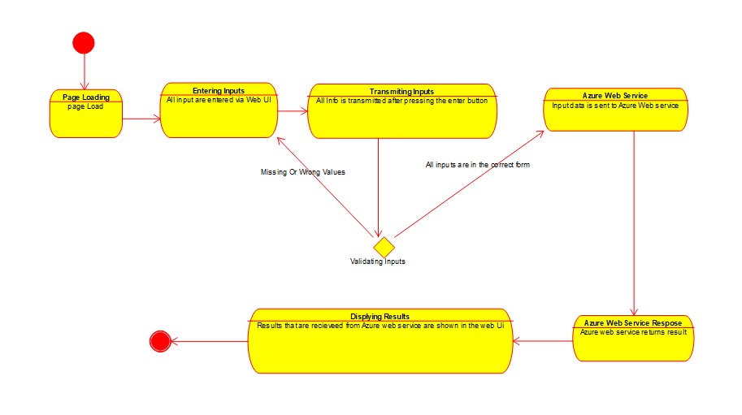

Azure Web service System : this is a web service system that help a website collect information from a user on the website and validate the information entered by the user and then stores this information. The web service then gets the information of the user that tis stored and displays the information retrieved .

This system consist of website where the user loads the page, then the user enters the information .The system validates the information of the user, if invalid the system then the system ask user to correct data .once the system gets valid information , it send the information to the azure web service . when the information is needed again the web service will retrieve the information from azure and display.